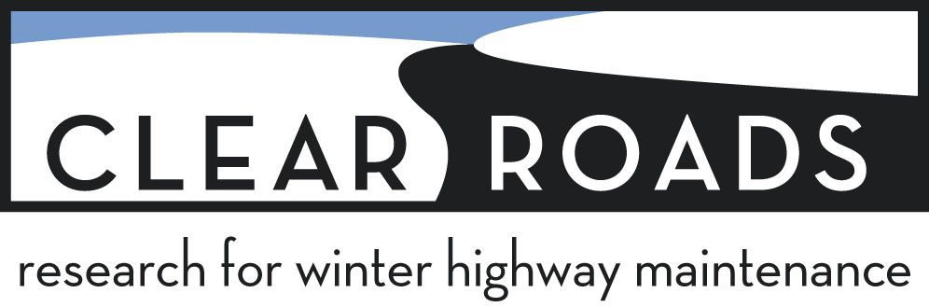

Summary of Work Accomplished, and Analysis and Recommendation of New Direction for the Clear Roads Study – Establishing Effective Salt and Anti-icing Application Rates

Background:
The desire for a set of standardized anti-icer chemical application rate recommendations had been a common theme for winter operations professionals at the first three Peer Exchanges in Columbus, Madison, and Bozeman. In fact, in the voting for various research projects to pursue, material application rate direction based upon lab and/or field research was the top vote-getter every time. This held true despite the existence of previous study (and application recommendations) on this topic, including the 1996 Manual of Practice for an Effective Anti-icing Program, the 2004 NCHRP Report 526, and other assorted studies.

The fact that there remained a strongly-held desire for material application rate guidelines among winter professionals led to two conclusions. The first conclusion was that the pre-existing guidelines were outdated by virtue of more recent innovations in practice and improvements to anti-icing chemical performance. The other conclusion, and the one which in retrospect should have been more strongly considered, is that there was general unawareness of the previously published guidelines. Interestingly, and despite such unawareness, it has become abundantly clear that most agencies are adhering rather closely to the principles of application recommendation espoused in the previously mentioned studies. This is to say that despite the relatively “dated” nature of the Manual of Practice (in particular) and other research including NCHRP Report 526, the state of practice for material applications has apparently not changed greatly in the ensuing years.

After several years of discussion at various venues as to how to pursue research into a “new and improved” set of application guidelines, Clear Roads members Paul Brown and Monty Mills drafted a problem statement for consideration at the 2012 Spring Clear Roads meeting. The project was approved and eventually awarded to Blackburn and Associates. The importance and wide interest in this particular project motivated us (Paul and I) to approach several highly regarded winter operations professionals outside of Clear Roads for service on the TAC. These included Wilf Nixon, Mark Devries, and Max Perchanok with Dave Wieder, Tom Peters, Tina Greenfield, and Larry Gangl serving as the Clear Roads team with Paul Brown and Monty Mills as Co-Champions.

The Project: Establishing Effective Salt and Anti-icing Application Rates
In brief, the goals of this project were to review previous research on this subject; survey and interview practitioners and vendors as to current practice and specific product qualities and expense; review application rates guidelines currently in use by agencies for various chemicals, weather events and road types; and ultimately to produce updated application rate guidelines based upon these findings.

There were a great many supplemental tasks which contributed to this effort, and which have added significant value to this field of research. Among these supplemental tasks were:
- The establishment of equivalent values for liquid application rates based upon their solid counterparts.
- Phase diagram plots of various chemicals based on a number of parameters.
- Comparative tables for chemical performance using NaCl as a baseline.
- Tables for minimum temperature bands for solid and liquid applications of various chemicals.
- In depth discussion of chemical characteristics pertaining to the most commonly used anti-icer products and several inhibitors/enhancers.
- A tutorial on ice melting chemistry and the interpretation of phase diagrams as they relate to chemicals used in deicing.
- A great deal of information from agencies on the chemicals they use, costs, and the weather parameters by which they determine application rates.

Findings/Challenges:
One of the products of Task 2 of this study was an appendix with updated application rates for solid and liquid NaCl. The researchers used directly equivalent application rates for liquid sodium chloride as compared to solid salt. This resulted in what the TAC felt were very high liquid application rates. During extended conversations between the researchers and the TAC on this issue it became clear that the academic approach to liquid application rates differs greatly from the practitioner approach, at least as it currently stands. While it makes perfect sense from an academic standpoint to use directly proportionate rates for liquid and solid anti-icers to attack similar road conditions, the fact remains that the use of liquid anti-icers at these “high” rates is not common practice.

The reasons for this are many, but negative experience with higher rate liquid applications is very common within the industry, and has provided many a cautionary tale about such applications. Understandably the researchers are hesitant to publish updated application rates that don’t provide direct equivalencies (solid and liquid) as to active ingredient for the treatment or prevention of ice and snow conditions. It would be problematic from a research standpoint to provide differing application rate guidelines for liquids and solids based upon the empirical rather than the scientific approach. However, the TAC strongly feels that publishing equivalent liquid application rates may encourage agencies with insufficient training on the use of liquid anti-icers to apply at rates which could lead to chemical slipperiness and other issues.

It also became clear during this study through surveys and interviews with practitioners that the state of practice has not substantially changed over the years since the publication of The Manual of Practice and NCHRP Report 526. This was initially somewhat surprising given the many changes and improvements to anti-icing chemicals that have occurred in the interim. But it is apparent that the basics of chemical anti-icing have not changed so radically as to alter the recommendations provided in those earlier publications.

Next Steps:
Given all of this the TAC has decided that the continuation of this project towards a set of updated guidelines is not necessary or justified. It is felt that existing guidelines such as those in the Manual of Practice are still relevant as a baseline for snow and ice material application rates. This project is therefore being ended early, although not without great appreciation for the work that has been accomplished by Blackburn and Associates. That work will be useful in itself for those who desire a deeper understanding of anti-icing chemical science. It will also provide a basis for the logical next step of this field of study, which we feel is to pursue an in depth synthesis of current practice in the field of anti-icing. This will be a new and independent project which the Clear Roads Pooled Fund group will review and vote upon. The problem statement for that Synthesis is attached.

Respectfully,

Monty Mills
WSDOT (Retired)

