**STEPS TO SAVE AND VIEW THE MODULE OUTPUT**

Please follow the following steps:

1. Select the downloadable link given below and download the file.

Example: <https://wow.focuseduvation.com/Sample/Clear_Roads/SSI_WSI_Variables/SSI_WSI_for_Snow_Ice_Manager.zip>

1. Right click and select the option “**Extract All**” to unzip and save the folder as shown in the screenshot below

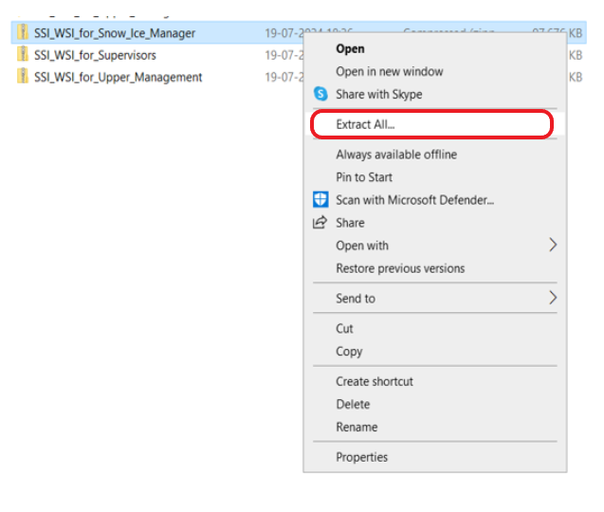

1. Double click the extracted folder to view the files, the files will be listed as shown below

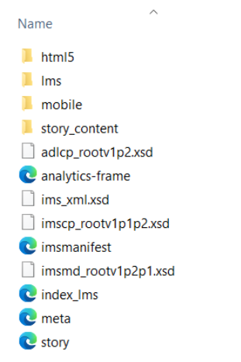

4. Select the file named story marked below in the screenshot to view the output:

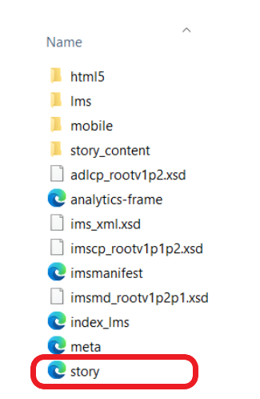

**Please note**: All the supporting files in the folder are necessary to view the output