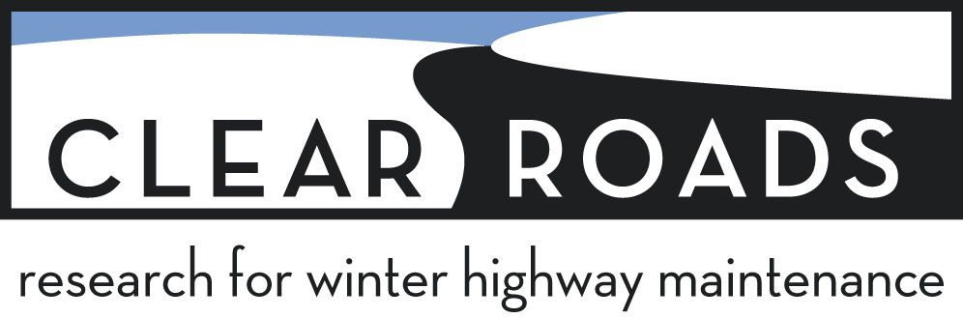

Research Idea Submission Form

Instructions: To submit an idea for consideration as a future Clear Roads research topic, please email this completed form to Greg Waidley at greg.waidley@ctcandassociates.com by December 31. Submitted research ideas will be considered by the Clear Roads Technical Advisory Committee (TAC), alongside research problem statements developed by TAC members, beginning in January. The ideas and problem statements that best meet Clear Roads’ priorities will be developed into full-scale research solicitations (RFPs) and posted by Minnesota DOT for competitive bid. For more information about Clear Roads’ research focus areas, please visit the Clear Roads website.

Proposer name:

Organization:

Title of proposed research project:

Topic Area (highlight one):
Planning/Methods Equipment Materials Training Technology Safety

- Explain the specific problem or issue to address.

- What is the goal of the project?

- Are you aware of any similar or related research on this topic? If so, please list below.

DISCLAIMER: Clear Roads considers many research ideas each year, and there is no guarantee that a submitted idea will be selected by the Clear Roads TAC for funding as a research project. Submitted ideas may be significantly altered by Clear Roads during the project scoping process. Selected ideas will be developed into Requests for Proposals (RFPs) and posted by Minnesota DOT for competitive bid. Research ideas will be shared among the Clear Roads membership (39 state DOTs), so please do not include any proprietary data or information that you do not want made available to the public. University researchers and consultants are encouraged to submit ideas for consideration; however, there is no guarantee that the research contract developed from an idea will be awarded to the original submitter.

